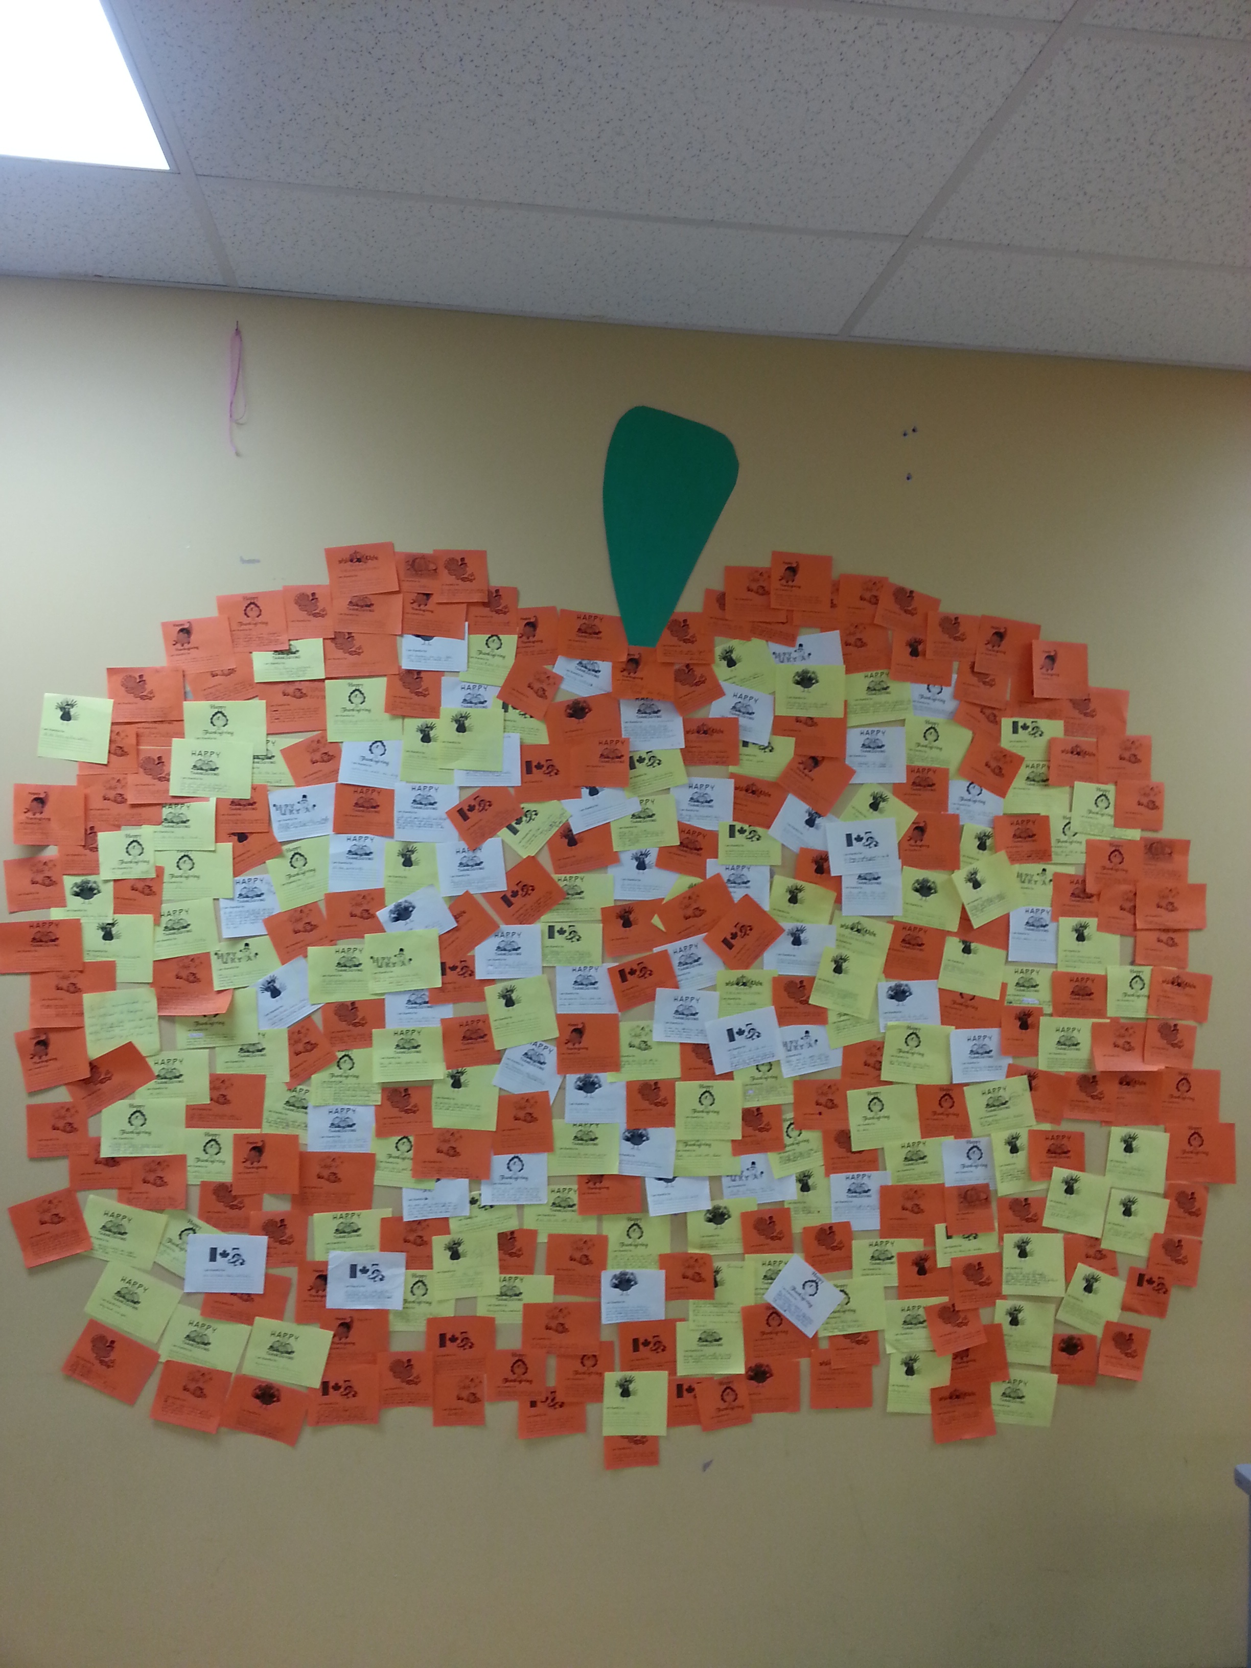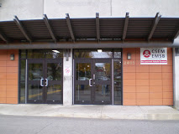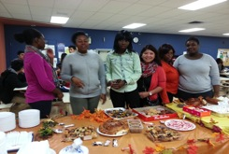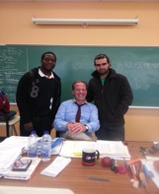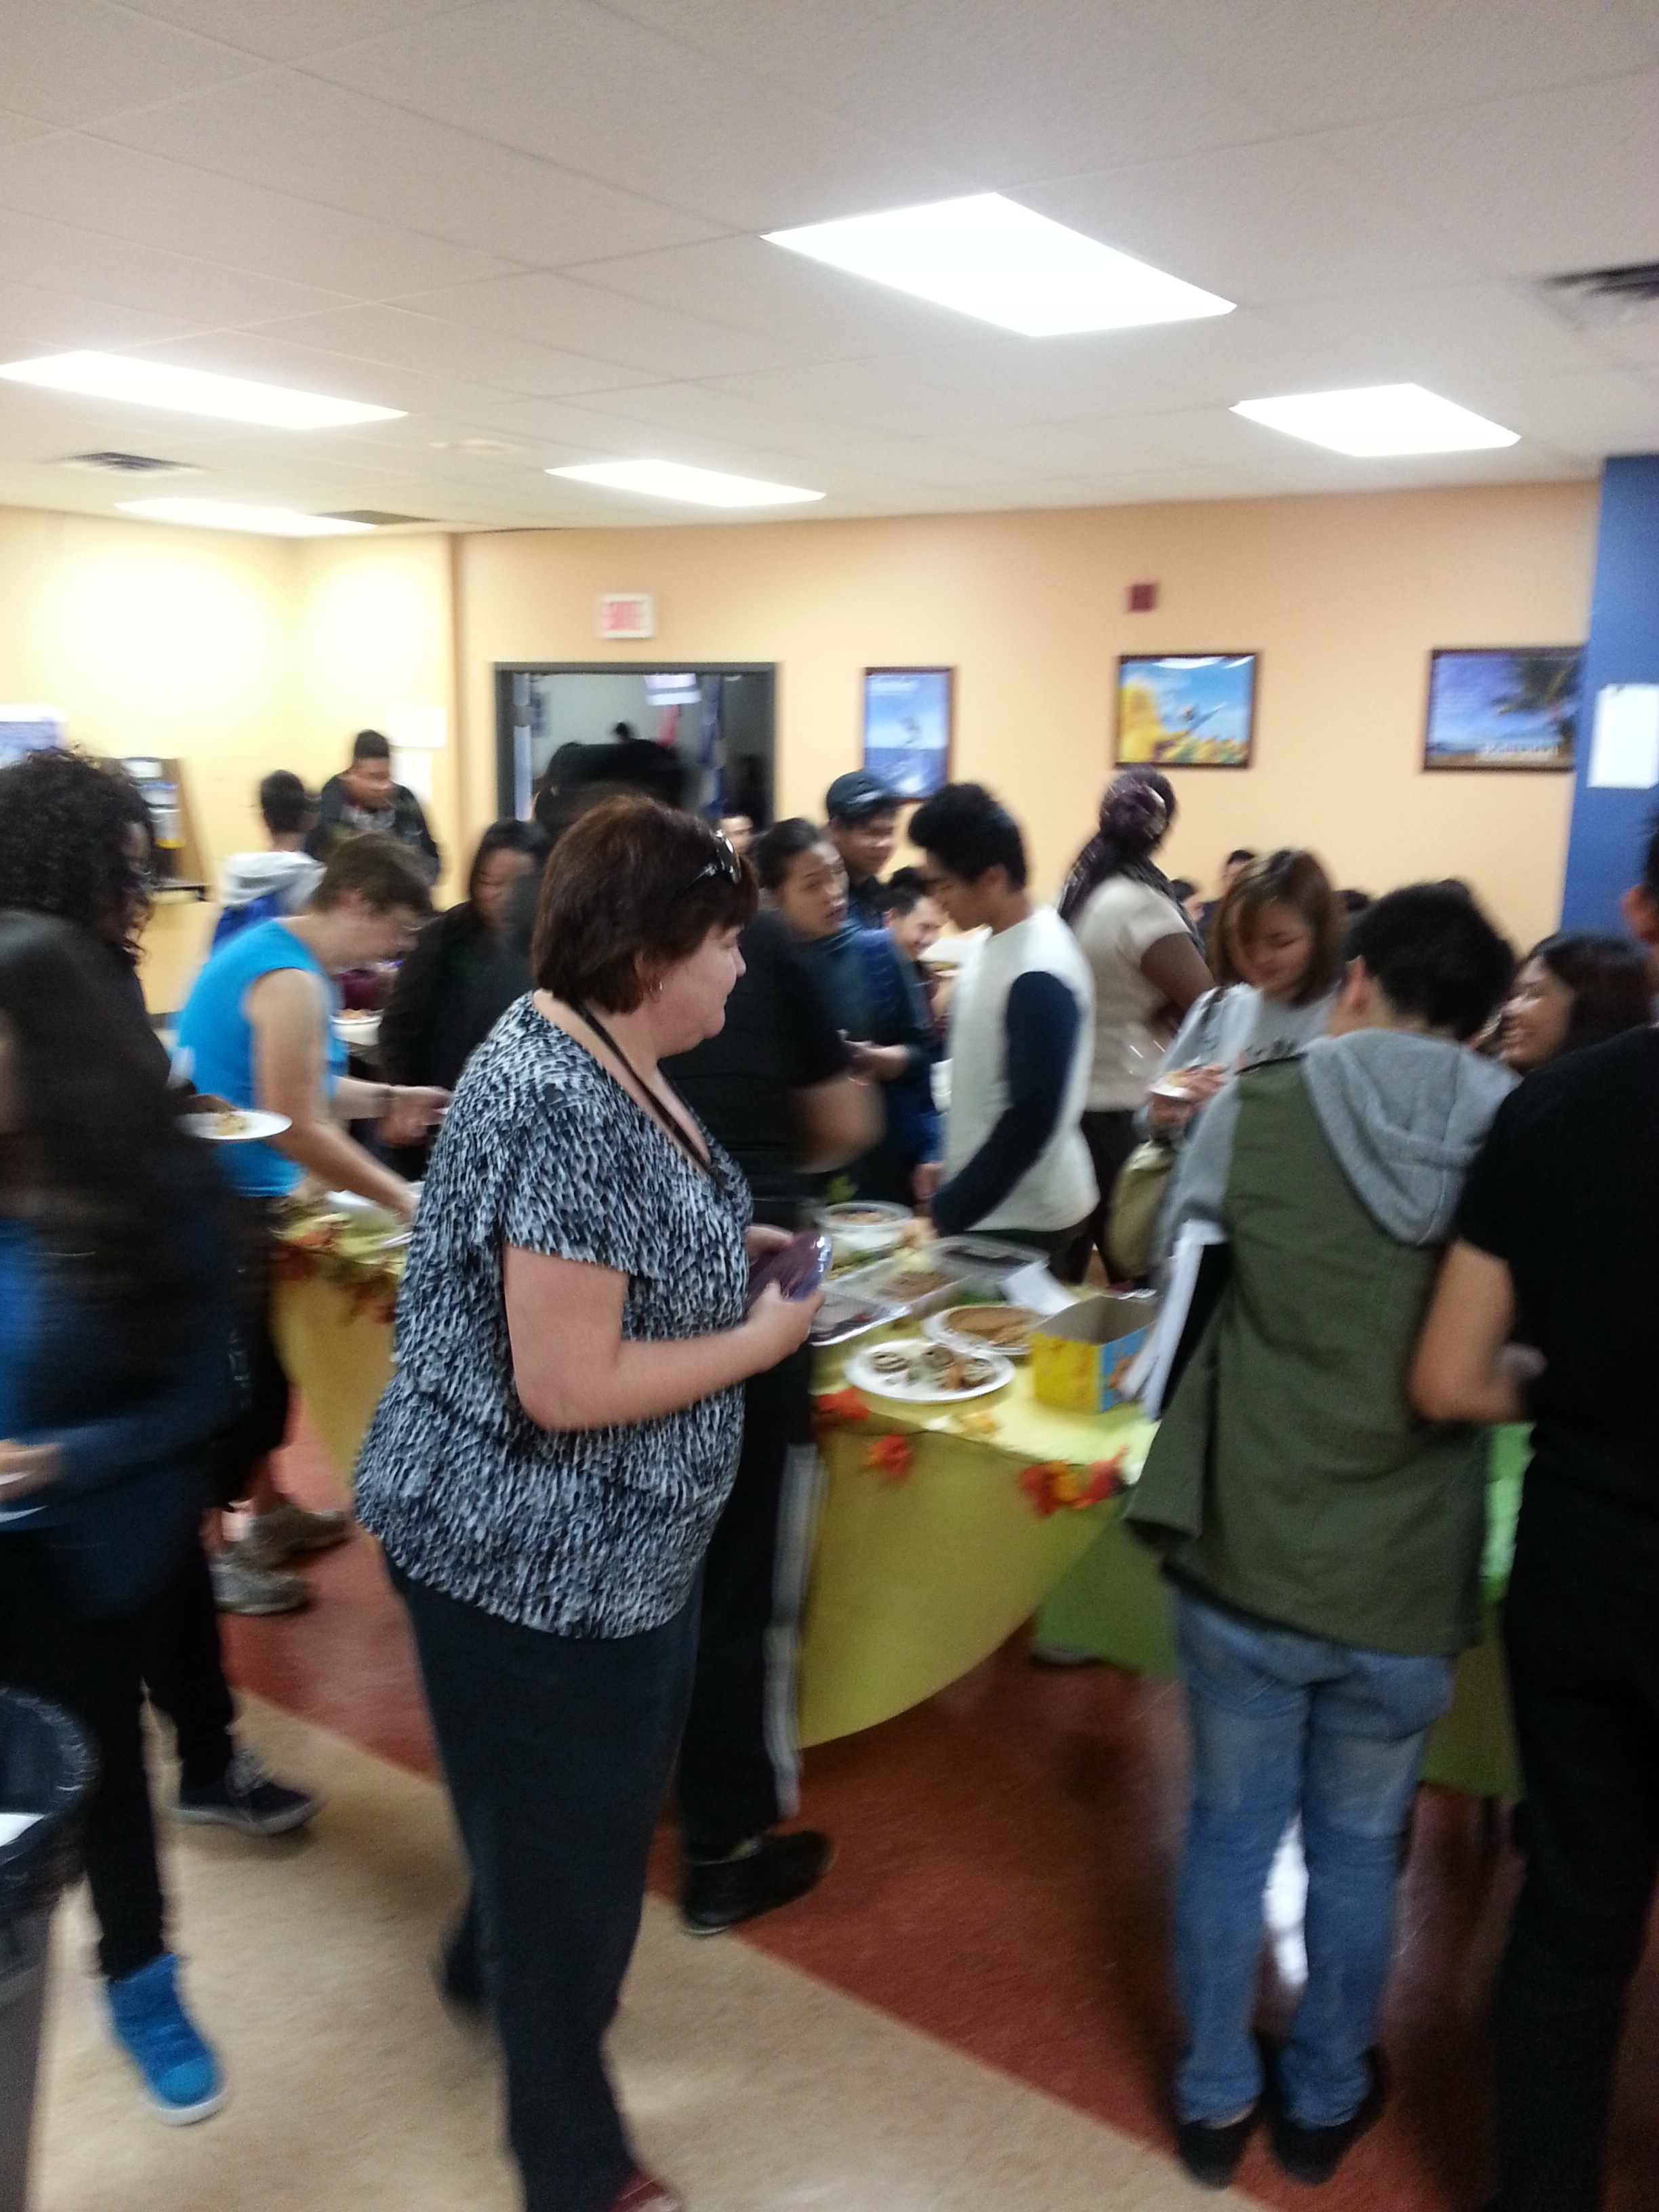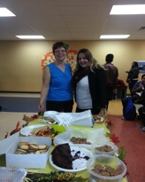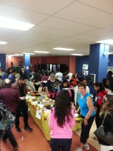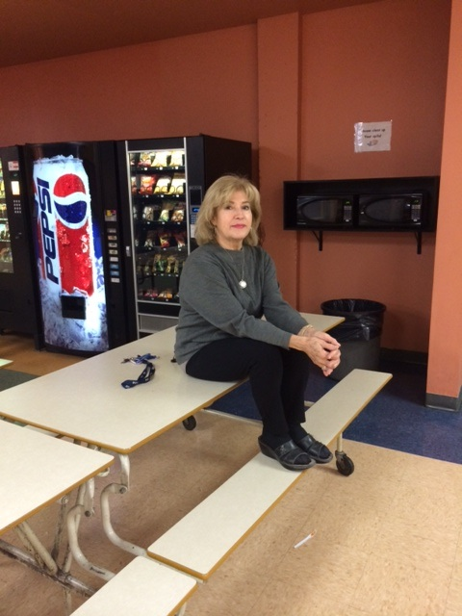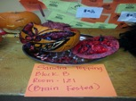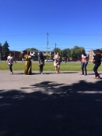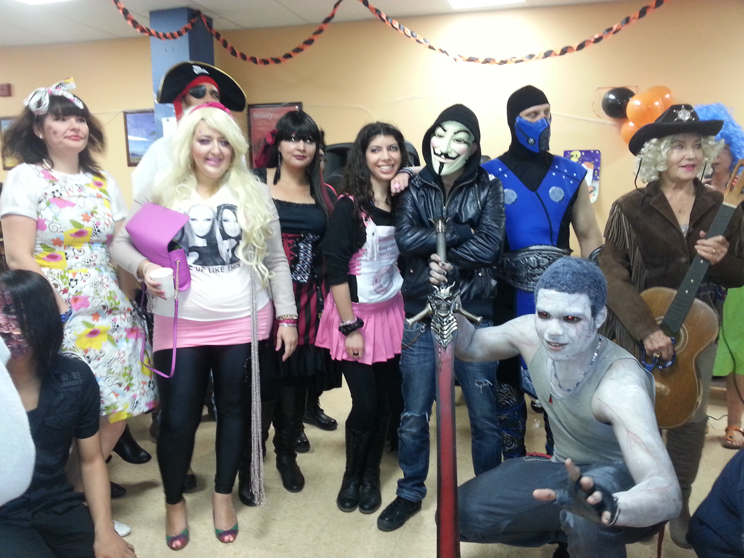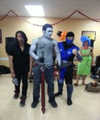

***Find more cool features like surveys, polls, submission & contact forms along with tons of pictures on our website!***

### *Lest We Forget*

Le Jour du Souvenir: deeper meaning than you thought.

**Published by Students for Students**

**Find us online at: www.stlaurentexpress.weebly.com**

# **IN FLANDERS FIELDS: *By Lieutenant Colonel John McCrae***

**In Flanders fields the poppies blow, Between the crosses, row on row, That mark our place: and in the sky**  
**The larks still bravely singing fly, Scarce heard amid the guns below.**

**We are the dead: Short days ago,**  
**We lived, felt dawn, saw sunset glow,**  
**Loved and were loved: and now we lie**  
**In Flanders fields!**

**Take up our quarrel with the foe**  
**To you, from failing hands, we throw**  
**The torch: be yours to hold it high**  
**If ye break faith with us who die,**  
**We shall not sleep,**

**though poppies grow**  
**In Flanders fields**

*Welcome to our first edition of the St. Laurent Express! On behalf of this newspaper, we wish to inform you on our academic courses and school activities. Enjoy your reading and your feedback is appreciated!*

*Bienvenue á notre première édition du St. Laurent Express! Par le biais de ce journal, nous souhaitons vous tenir informés des activités de l’école et de ce qui est fait en classe. Bonne lecture…et n’hésitez pas à donner vos impressions!*

**St. Laurent Express**

Fri. Nov. 7th & Fri. Nov. 28th

Enjoy your time off and don’t forget to use it wisely ☺

Success is at your fingertips. Be positive and study hard!

Tues. Nov.11th

As the next session slowly approaches…NOW (not tomorrow) is the time to assess yourself! Your grades, attitude, motivation and habits ALL play a huge role in your success! Words of advice:

*“If you don't go after what you want, you'll never have it. If you don't ask, the answer is always no. If you don't step forward, you're always in the same place.”*

*– Nora Roberts*

#### Save The Dates!

Mon. Dec. 1st

##### New Session Begins

##### Remembrance Day

##### Ped. Days

# School News!

# *What’s happening in your school community?*

FALL 2014

Student Council is a great way to get to know your **school community** on a closer basis, make connections, have **your voice** heard and develop leadership skills! Find out how you can **get involved** in your school community and make a difference! See Ria for more information!

Did you know that **Soccer** or **Futball** (depending where you’re from) is played by **250 million players** in over **200 countries**…making it the world’s most popular sport! Well, if you’re interested, Mr. Marques is kick-starting (literally) a St. Laurent soccer team! Sign up A.S.A.P. Also, join him every Thursday after school for the Reading Club in room 117.

Happy November to all of St. Laurent Adult Centre students! We hope you all had a safe and

**SPOOOKTACULAR** Halloween!! During the last two months of the school year, we have held a **corn boil** to welcome our students and have them socialize. In addition, to start this cool and fresh autumn season,

the school hosted a delicious **Thanksgiving Day sweets table** where students and staff joined in to show their thanks and appreciation. In Addition to all the

wonderful events here at St. Laurent. We are convinced that this will be an **amazing academic year**!

1. The “**Movember”** Foundation challenges men to grow their moustaches during the month of **Movember** (formerly known as November), to spark conversation and raise **awareness** and funds for its **men's health** programs. This work is saving and improving the lives of men affected by prostate cancer, testicular cancer and mental health issues.

What Exactly is Movember, Anyway?

Meet The Student Council Team

# Happy November!

Health & Fitness: Soccer Team

**A Message From The Science Department!**

What is science? What does science tell us about **ourselves**? Is there more to science than forces, electromagnets, test tubes, or **frogs waiting to be dissected**? The answer to these questions is that science takes one on a journey, a journey in search of true knowledge. The origin of the word science comes from the Latin “**scientia**” which means **knowledge**. Science is a way of **really** looking at the world and understanding why things are as they are.

We offer courses in four areas of science-biology, physical science, physics and chemistry. The study of science will open many doors so that you can. **“Live your life as an exclamation rather than an explanation.” (Sir Isaac Newton)**

***Irena Najdowski***

Ever wonder how **Einstein** invented the atomic bomb, why **global warming** is creating climate change, why **acids burn** your skin, how electricity makes a light bulb burn or why the Earth has a **magnetic field**? Why not take a **Physical Science** course and find out!

***Lisa Parente***

**Questions MOST Asked by Students:**

**Q.1:**Why don't we have **sports activities**?

**Q.2:**Can we have more **field trips**for each

discipline?

**Q.3:**How can we raise money for new library **books**?

**Q.4:**Are we able to receive more choices for

**course options**?

**Q.5:**How can the school be more flexible with

**justified absences**?

**Q.6:**Can we have different **language courses**?

*Please submit your answers **via email**to

one of the members of the St. Laurent team or through our website.

The answers will be posted in the next edition of the VSL Express. Feel free to include further questions for investigation!

***Secondary 1 Math Student***

# **Ingredients**

4-5 orange pekoe teabags

1 stick of cinnamon

1 1/2 teaspoon fennel seeds

4 green cardamom seeds

Whole milk

5-6 teaspoons sugar

5 1/2 teacups water (the actual size of the cup in which you’ll serve tea)

# **Preparation**

You don’t need all of the spices to make chai. At home, we often just use green cardamom, and lots of it! Depending on the strength of tea you prefer, use 4 teabags for a milder flavor. The amount of sugar should also be adjusted to your preference. Break the cardamom seeds. Place the cinnamon, fennel, cardamom, sugar and water in a saucepan and bring to a boil. Once the water is boiling, add the teabags and let boil for another minute. Add 3/4 to 1 teacup of milk, bring to an almost boil and remove immediately from stove. Remove teabags. Pour tea through a strainer and into a teapot or directly into teacups. Serve while very hot. Once the chai has cooled, it should not be reheated!

# Student Recipe: Masala Chai Tea

*This recipe will surely keep you warm and cozy during the colder months to come…enjoy! This is actually a combination of her grandma and mother’s chai recipe.*

# Our Thanksgiving Celebration

Candy Cane-O-Grams! Looking to spread a little Christmas cheer to

your friends? Well, look no further! During the month of **December**, come purchase your little piece of holiday sweetness.

Keep your eyes open for this year’s **upcoming school movie**! Watch students act in a **modern day** version of Charles Dickens’ classic

“**A Christmas Carol**,” a tale of the love and magic of Christmas. Join us while Ebenezer Scrooge is taught the real meaning of the holiday while he travels back in time through his life to **make amends** with himself!

Details will be available soon through the St. Laurent

Express, please **stay tuned**!

## La biographie d’un professeur: Suzanne Turp

Suzanne est née à Montréal, sa mère est française et son père écossais. Elle a un seul frère nommé Gerry. Suzanne est une personne très **active**, peu importe la saison. Elle fait du **Taï Chi** depuis cinq ans. Elle adore faire du **ski** en hiver et du **vélo** en été. Elle a trois enfants: **deux filles et un garçon.** Elle aime beaucoup les chats et en a un noir qui s’appelle Max. Quand il est temps que son chat rentre à l’intérieur, elle siffle les premières notes de la symphonie numéro cinq de **Beethoven** et il rentre chez lui. Mon professeur de français aime beaucoup la **bibliothèque**, elle lit au moins un livre par semaine. Elle est toujours de bonne humeur, **chaleureuse** et prend à cœur ses élèves.

Happy Halloween to all of our wonderful students here at

St. Laurent, we do hope it was a **safe and fun holiday**! Here are some pictures of our celebration with the winner of **'best costume’** and **‘best pumpkin carving.’** TheHalloween celebration was a lot of fun and the haunted house was truly spooky and one of a kind!

Halloween ou l'Halloween (usage québécois) est une fête originaire des îles Anglo-Celtes-célébrée dans la soirée du **31 octobre**, veille de la Toussaint. Son nom est une contraction de l'anglais *All Hallows Eve* qui signifie *the eve of All Saints' Day* en anglais contemporain et peut se traduire comme “**la veillée de la Toussaint**.”

## Halloween Madness: Haunted House, Best Costume & Best Pumpkin

The Corn Boil was a huge **success**! Students had the chance to be introduced to one another, to dance to the sound of the **DJ’s beats** and to just **enjoy** the last few **rays of sunshine** that the end of summer sun had to offer us! Ms. Sandra did a great job of getting everyone on the ‘**dance floor**’ (a.k.a. the schoolyard)!

## Corn Boil

# St. Laurent Memories

## Coming Soon…

**TRIVIA:**

**How Canadian Are You, EH?**

**Q1: I*n what province did***

***the ''Marathon of Hope's” creator and Canadian***

***hero Terry Fox spend most of his life****?*

A: Quebec

B: New Brunswick

C: Manitoba

D: British Columbia

**Q2: *What is the population of***

***Canada?***

A: 30 Million

B: 23 Million

C: 32 Million

D: 72 Million

**Q3: *Where does the word Canada come from?***

A: Jacques Cartier

B: Samuel de Champlain

C: Jean Nicolet

We all define education differently and although we may have different views, one factors remains common: education is essential to humanity. Education is very important because it can lead us on different paths and at the end of most of them we will find greater opportunities.

Some people will say that education is the key to success. It is true, especially in the developing countries like the Philippines. Canada and the Philippines have huge differences concerning their education systems. For example, here in Canada, public schools have free education for both primary and secondary. Also, we have the choice to finish our studies in adult school. On the other hand, in Philippines, you need to pay before attending any school. In Quebec, CEGEP prepares students for University, but in the Philippines, there’s no preparation stage before University. In the Philippines, we can choose between private and public schools but the difference is that in the public sector, it’s less expensive and the service might not be as good as when you’re studying in the private sector.

Private schools have more advantages than public schools regarding their curriculum but it’s much more expensive. This is also why education is a must to Filipinos because of their financial situations. We want to have a better life and a better future, so we always give our best and aim for the best. Even though we have advanced education, most people don’t have a chance to finish their studies because of economical problems and are forced to stop and find a job to be able to survive in their daily lives. Students here are lucky because they’re studying in a developed country that have a free and good quality education system and also unlimited opportunities.

It is good to work while studying but never neglect your studies. For me, the purpose of Education is to turn mirrors into windows. Getting formal education can unlock many opportunities. You can always grasp ‘the bigger picture’ when you have a proper education. Take advantage of this gift, aim high and education can bring you anywhere.

***Secondary: English 3 Student***

# Editorial:

# Changing Settings, Maintaining Values

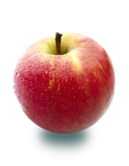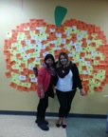

Your battle is now over, no more tears flowing down your cheek,

no more pain, no more suffering, now you are no longer weak.

I still don’t understand why this had to happen to you,

but I am proud to say you are my dad, the greatest man I ever knew.

Although you will not be here to walk me down the aisle,

when that day comes I know you will be by my side with a smile.

You were always there for me and never once made me cry,

until the day you closed your eyes and had to say goodbye.

Now you are my angles, so spread your wings out wide,

please wrap them around me whenever you see me cry.

Our time together was memorable and God took you away too fast,

but the most precious thing to me was you being there for my first breath,

and me being there for your last.

Ms. Lisa, Mr. Joseph, Mr. Tom, Sam, Kylia, Mary Jane & Vilma

*The St. Laurent Express Team*

*We Hope You Enjoyed! ☺*

Ms. Lisa Trotto: misstrotto@gmail.com

Mr. Joseph Marques: teach.jmm@hotmail.com

Mr. Tom Patrick: patricktl@hotmail.com

Samantha: samantha.horan1022@gmail.com

Kylia: miss_isaac@hotmail.com

Vilma: nsi.1services@yahoo.ca

Mary Jane: khenjhane18@gmail.com

Your Battle is Now Over

*This heart-touching poem was written after a Secondary: English 2 student lost her father in 2013.*

Contact Us!

|  |  |  |  |  |  |
| --- | --- | --- | --- | --- | --- |
|  | **Mon.** | **Tues.** | **Wed.** | **Thurs.** | **Fri.** |
| **Ervie**  **(**Math/  Science) | 9:00 a.m. – 3:00 p.m. |  | 11:00 a.m. – 3:00 p.m. |  | 11:00 a.m. – 3:00 p.m. |
| **Bettina**  (English/  French) | 9:00 a.m. – 3:00 p.m. | 12:45 p.m. – 3:00 p.m. | 9:00 a.m. – 3:00 p.m. | 12:45 p.m. – 3:00 p.m. |  |
| **Adele**  (All Subjects) |  | 9:00 a.m. – 3:00 p.m. |  | 9:00 a.m. – 3:00 p.m. |  |

**Staff Tutoring Hours:**

|  |  |  |  |  |  |
| --- | --- | --- | --- | --- | --- |
|  | **Mon.** | **Tues.** | **Wed.** | **Thurs.** | **Fri.** |
| **“A” Block** |  |  |  |  |  |
| **“B” Block** | Nandita  Rm. 128 |  |  |  |  |
| **“C” Block** |  | Yaw |  |  |  |
| **After School** | Sandra | Yaw | Andrew | Douglas | Lisa P. |
|  | Joseph | Lisa T. | Tom | Joseph (Reading Club) |  |

FALL 2014

Inspiring story